SDP Portal

Submitted in partial fulfillment of the requirements of the Degree of

**Bachelor of Engineering** in

**Computer Engineering**

by

*Swara Kiran Rane 121A1086*

*Shreya Limkar 121A1104*

*Srushti Tambe 121A1111*

*Ketaki Vatturkar 121A1119*

Under the guidance of:

*Prof. Suvarna Chaure*

**Department of Computer Engineering SIES Graduate School of Technology Nerul, Navi Mumbai - 400 706**

**University of Mumbai**

**(AY 2024-25)**

# Certificate

This is to certify that the Mini Project entitled *“****SDP Portal****”* is a bona fide work of the following students, submitted to the University of Mumbai in partial fulfillment of the requirement for the award of the degree of **Bachelor of Engineering** in **Computer Engineering.**

*Swara Kiran Rane 121A1086*

*Shreya Limkar 121A1104*

*Srushti Tambe 121A1111*

*Ketaki Vatturkar 121A1119*

1. Internal guide signature …………………………………….

(Prof. Suvarna Chaure)

1. Head of department signature ………………………………………

(Dr. Aparna Bannore)

1. Principal signature ………………………………………

(Dr. K. Lakshmisudha)

# Mini Project Approval

This Mini Project entitled *“****SDP Portal****”* by following students is approved for the degree of **Bachelor of Engineering** in **Computer Engineering.**

*Swara Kiran Rane 121A1086*

*Shreya Limkar 121A1104*

*Srushti Tambe 121A1111*

*Ketaki Vatturkar 121A1119*

### Examiners

1……………………………………. (Internal Examiner Name & Sign)

2……………………………………… (External Examiner name & Sign)

Date:

Place: Nerul

Department of Computer Engineering

**Table of Contents**

Certificate ii

Mini Project Approval iii

Abstract v

Acknowledgement vi

List of Figures viii

Chapter 1: Introduction 1

* 1. Introduction 1
  2. Motivation 2
  3. Problem statement and Objectives 2
  4. Organization of report 3

Chapter 2: Literature Survey 4

* 1. Survey of existing system 4
  2. Limitations of above existing system 5

Chapter 3: Proposed System 8

* 1. Architecture and Framework 9
  2. Algorithm and Process Design 9
     1. Login for student & professors 9
     2. Uploading & course selection 10
     3. Course 10
     4. Database 11
  3. Details of Hardware and Software 11
  4. Experiment and Results 11

Chapter 4: Conclusion 15

* 1. Future Scope 15
  2. Conclusion 15

References 17

# Abstract

The Student Development Program (SDP) plays a pivotal role in engineering education, serving as a platform for holistic development beyond academics. This project aims to conceptualize, design, and build a web application that not only streamlines the administrative tasks associated with the SDP but also enhances its effectiveness in fostering the personal and professional growth of engineering students. The project's foundation lies in a thorough analysis of the current SDP framework, including its objectives, key components, and the challenges faced in its administration. This preliminary research is vital to understand the specific needs and pain points of the program, which will guide the web application's development.

The project employs agile methodologies to ensure adaptability to changing requirements, as the educational landscape continually evolves. Iterative development cycles and feedback loops play a pivotal role in crafting a user-centric solution that addresses the unique demands of engineering students. Moreover, a robust database schema is designed to accommodate various types of data, from student records to program activities. This comprehensive data management ensures the web application can store, retrieve, and analyze information efficiently, ultimately leading to data-driven decision-making for program improvements.

User experience (UX) and user interface (UI) design are integral components of the web application. The aim is to create an intuitive and visually appealing platform that resonates with engineering students. The design process will involve wireframing, prototyping, and usability testing to refine the user interface for maximum usability and engagement. To make the web application accessible to a diverse audience, including students, faculty, and administrators, responsive design techniques will be implemented, ensuring an optimal user experience on various devices and screen sizes.

Incorporating security measures is of paramount importance in this project, as the web application will handle sensitive student information. Robust security features, including data encryption, user authentication, and authorization mechanisms, will be integrated to protect against data breaches and ensure compliance with data protection regulations. The project will address the issue of scalability by employing cloud-based infrastructure, which allows for seamless expansion as the SDP grows. Cloud services offer benefits in terms of reliability, performance, and cost-efficiency, making them a suitable choice for hosting the web application.

The implementation of interactive features, such as progress tracking, event scheduling, and communication tools, is crucial to enhancing the student experience. Gamification elements may be incorporated to motivate student participation and engagement within the SDP. Accessibility and inclusivity will be key considerations during the web application's development. This involves adhering to web content accessibility guidelines (WCAG) to ensure that the application is usable by individuals with disabilities, thus promoting a more inclusive educational environment.

# 

# 

# Acknowledgement

We would like to express our thanks to the people who have helped us the most throughout our project. We are grateful to our guide **Prof. Suvarna Chaure** and coordinator **Prof. Sunil Punjabi** for nonstop support for the project.

A special thanks goes to each other who worked together as a team in completing the project, where we all exchanged our own interesting ideas, thoughts and made it possible to complete our project with all accurate information. We also wish to thank our parents for their personal support and attention who inspired me to go my own way.

We would also like to extend our sincere gratitude to our Principal **Dr. K Lakshmisudha** and our Head of the Department **Dr. Aparna Bannore** for their continuous support and encouragement.

We also would like to thank our other faculty members for providing us with all the required resources and references for the project.

# List of Figures

Fig 3.1 Architecture of proposed system

Fig 3.2 Login for student & faculty

Fig 3.3 Uploading and course selection

Fig 3.4 Courses description

Fig 3.5 Database

Fig 3.6 Homepage

Fig 3.7 Course selection list

Fig 3.8 Selected course list

Fig 3.9 Login Module

# Chapter 1: Introduction

## 1.1 Introduction

SIES GST, renowned for its commitment to academic excellence and holistic development, offers a comprehensive Student Development Program (SDP) tailored to students pursuing engineering courses. The SDP at SIES College plays a pivotal role in shaping well-rounded individuals who not only excel academically but also possess the skills, knowledge, and values required to succeed in today's dynamic and competitive engineering landscape.

SIES College, founded with a rich history and a commitment to fostering holistic growth, understands that education transcends the classroom. In engineering education, practical skills, soft skills, and a deep understanding of industry dynamics are just as important as theoretical knowledge. The SDP at SIES College bridges this gap by providing a structured and multifaceted approach to student development.

One of the primary objectives of the SDP is to equip engineering students with the tools necessary to excel in their academic pursuits. SIES College boasts a faculty of experienced and accomplished educators who are not only experts in their respective fields but also mentors dedicated to guiding students on their academic journey. With access to state-of-the-art laboratories, modern teaching methodologies, and a rich academic environment, students receive a strong foundation in engineering principles and practice.

However, the SDP goes beyond academics. It is designed to nurture well-rounded individuals who are prepared to face the challenges of the real world. Communication skills, leadership abilities, teamwork, and problem-solving are integral components of the program. SIES College offers a range of co-curricular activities, workshops, and seminars to hone these essential skills. Engaging in extracurricular activities is encouraged, and students are provided with ample opportunities to participate in clubs, competitions, and events.

The engineering industry is evolving at an unprecedented pace, and it is essential for students to stay updated with the latest developments. The SDP at SIES College ensures that students are not only well-versed in traditional engineering disciplines but are also exposed to emerging technologies and trends. Guest lectures by industry experts, internships, and collaborative research projects enable students to gain practical exposure and insights into the real-world applications of engineering principles.

The program also emphasizes values and ethics, instilling a strong sense of social responsibility in engineering students. SIES College believes that engineers of the future should not only be technically proficient but also have a deep understanding of their ethical responsibilities to society and the environment. As a result, the SDP incorporates courses and activities that promote ethical behavior, sustainability, and community engagement.

In the ever-competitive job market, the SDP at SIES College takes a proactive approach to career development. It offers comprehensive career counseling, resume-building workshops, and interview preparation to ensure that engineering students are well-prepared to enter the workforce. The college has a strong network of alumni and industry connections, facilitating internships and job placements for its graduates.

Additionally, the SDP at SIES College recognizes the importance of research and innovation in engineering education. It encourages students to explore their creative and innovative potential by providing access to research facilities, mentorship from experienced faculty, and opportunities to participate in research projects. The goal is to nurture a culture of innovation and entrepreneurship among engineering students.

## 1.2 Motivation

The motivation behind our SDP (Student Development Program) College Portal is to enhance the overall educational experience of our students by providing them with a convenient platform to access and engage in extracurricular programs offered by the college after every semester. Our primary goal is to foster an environment where active participation and learning outside of traditional classroom settings are not only encouraged but made easily accessible. This initiative is designed to empower our students to explore their interests, acquire new skills, and expand their horizons.

One of the core features of our portal is the ability to browse, test, and purchase extracurricular courses. This component is pivotal in ensuring that students have access to the resources they need to excel in their chosen areas of interest. Understanding that students often have busy schedules, and finding the time to participate in these programs can be challenging. The portal offers flexibility, allowing students to learn at their own pace and on their own schedule. By offering the opportunity to test these courses, students can make informed decisions about their choices, ensuring that they invest their time and resources in activities that align with their passions and goals.

Exploring beyond traditional subjects can broaden our tech knowledge, enhancing future experiences. Diving into creating a full-stack website for an SDP portal hones our ability to craft projects from scratch, infusing innovation and ideas. This practical endeavor equips us with vital skills, from coding and design to problem-solving. It fosters adaptability, critical thinking, and a deeper understanding of technology's role in our lives. By embracing diverse areas of learning, the website open doors to endless possibilities, ensuring that we're well-prepared for the ever-evolving tech landscape, where it can make a positive impact through our creations.

Moreover, the portal serves as a platform for students to interact with instructors, mentors, and peers. It fosters a sense of community and collaboration among students who share similar interests, which is essential for personal and professional growth. This interaction goes beyond just learning - it can lead to meaningful connections, partnerships, and even mentorship opportunities.

Additionally, the portal keeps a comprehensive record of a student's extracurricular achievements and skills acquired, which can be a valuable asset when it comes to job applications and career advancement. It's not just about learning; it's about demonstrating that learning to potential employers and showcasing the skills acquired through these programs.

**1.3 Problem statement and Objectives**

The Student Development Program (SDP) at SIES offers students a chance to explore diverse subjects outside their regular coursework. However, the absence of an SDP portal has placed additional demands on teachers. Moreover, many students face challenges in accessing this valuable program due to the burdens of travel. Therefore, the creation of an SDP portal has become imperative. This digital platform will streamline administrative tasks for educators, making the program more efficient. It will also extend the benefits of SDP to a wider student audience by eliminating the need for time-consuming travel, ensuring that all students can conveniently expand their knowledge across various fields through this short-term course.

Objectives:

* + - SDP portal tends to introduce flexibility and maintenance in the entire process, from enrolling to certificate generation to rendering video lectures.
    - It ensures to reduce workload of the faculty and reach more students with its benefits and resources
    - It provides a list of courses which helps the students know all the provided courses
    - It caters the student users to take course quizzes and tests

## 1.4 Organization of report

This report is structured into distinct chapters, each serving a specific purpose.

Chapter 1 initiates with an introduction to the project. It encompasses the project's objectives, the rationale behind the solution provided to address a particular problem, the project's problem statement, and an outline of the report's structure.

Moving on to Chapter 2, the focus shifts to a Literature Survey, delving into prior work in the field. This chapter explores historical approaches to the problem, their real-world implementations, and their associated limitations. Additionally, it introduces a contribution to a smaller project within this chapter.

Chapter 3, the Proposed System, underscores the significance of an efficient yet straightforward system. It provides a detailed explanation of the proposed system and how it addresses the shortcomings of the existing one. This chapter covers system design, elucidates the roles of various actors involved, and discusses the hardware and software components in the suggested system. It culminates with the presentation of experimental results.

The narrative culminates in Chapter 4, where various potential directions stemming from the current model are contemplated. This chapter outlines each of these paths within the scope of future work. Finally, the report concludes with a summarizing section that offers an overview of the entire document.

# Chapter 2: Literature Survey

## Survey of existing system

There have been numerous educational websites constructed for the various Universities, of which references were taken. Seven research papers for layout, design and implementation:

A University Website Design Project:[1] The Design Process, the Prototype and Some Design Issues-WebFeat was a Website design project undertaken on behalf of office departments and an administrative office of the University of Washington’s College of Engineering. The role of the WebFeat Core Team was to provide design and technical guidance for the six teams working directly with these units. The Core Team created a prototype from which the unit teams designed their individual sites. Later the Core Team helped implement the unit sites. As part of the design efSort, the Core Team examined numerous university Websites and thought through a variety of design issues. Three are discussed here: (I) indicating the identity of individual units within the hierarchical structure of the institution; (2) maintaining visual consistency throughout the site, and (3) harmonizing the messages conveyed by the university’s home page and the home pages of the university’s colleges and departments.

Analysis of University Websites for Study:[2] The use of websites in educational contexts is increasing day by day. There is a great impact of technology on the educational system. The technology has increased the usage of websites in educational contexts in India. The delivery of content through websites is possible due to the World Wide Web. It serves as a base for making the content available to the beneficiaries in no time.

Performance Evaluation of Malaysian University Website:[3] In recent years, many people have devoted their efforts to the issue of Web site performance. Web performance testing can be divided into many categories. It is usually performed in different aspects such as user interface, functionality, interface compatibility, load/stress, and security. This research investigates Malaysian university performance of the website under the World Wide Web environment. In the World Wide Web environment, this portal helps measure real data and obtain response time via the evaluation procedure.

The Design and Implementation of Responsive Web Page:[4] Based on HTML5 and CSS-The responsive web design solves the compatibility problems of web pages displayed at different resolutions, different platforms, and different screen sizes, and also brings high quality experience to users. Based on the research on responsive web design, and related technologies of HTML5 and CSS3, this paper expounds the design ideas and key technologies of responsive design with a responsive enterprise website. Response web design based on HTML5 and CSS3 has proved to be feasible and effective.

Developing an E-Commerce Website:[5] In many cases, brick-and mortar businesses are resorting to having a counterpart which is internet or e-commerce driven. People in the developed world and a growing number of people in the developing world now use ecommerce websites on a daily basis to make their everyday purchases. Still the proliferation of e-commerce in the underdeveloped world is not that great and there is a lot to desire for. This paper outlines different aspects of developing an ecommerce website and the optimum solution to the challenges involved in developing one.

Educational Web Portals of Higher Education and Their Problem-–In this paper, we will discuss the utilities of Educational Web Portals in higher education and evaluate a different type of web portals that provide different options of learning in the Higher education field. This study is based on the experiences students and scholars who are the part of a Facebook page community from all over India and they are engaged in Web-Based Learning and help each other through online communication

E- Learning Website:[6] The objective of this website will Enhance the quality of learning and teaching. Meet the learning style or needs of students. Improve the efficiency and effectiveness. Improve user-accessibility and time flexibility to engage learners in the learning process. Our E-learning website is GROOVE that will help you to learn online. And access free courses from our website.

## Limitations of above existing system

## Limitation of "A University Website Design Project: The Design Process, the Prototype and Some Design Issues-WebFeat":

## The paper is focused on a single university website design project, and its findings may not be generalizable to other universities.

## The paper does not discuss the long-term impact of the WebFeat project on the usability and effectiveness of the university website.

## The paper does not address the issue of how to design websites that are accessible to users with disabilities.

## Limitation of "Performance Evaluation of Malaysian University Website":

* The paper focuses on the performance of Malaysian university websites, and its findings may not be generalizable to universities in other countries.
* The paper does not discuss the impact of website performance on user satisfaction and engagement.
* The paper does not address the issue of how to improve the performance of university websites without sacrificing usability or content quality.

Limitation of "The Design and Implementation of Responsive Web Page Based on HTML5 and CSS":

* The paper focuses on the design and implementation of responsive web pages, but it does not discuss the usability and effectiveness of such web pages.
* The paper does not address the issue of how to design responsive web pages for users with disabilities.
* The paper does not discuss the challenges of implementing responsive web pages in large, complex websites.

Limitation of "Developing an E-Commerce Website":

* The paper focuses on the development of e-commerce websites in general, but it does not discuss the specific challenges of developing e-commerce websites for universities.
* The paper does not discuss the issue of how to secure e-commerce websites from cyberattacks.

1. The paper does not address the issue of how to comply with data protection regulations when developing and operating e-commerce websites.

Limitation of "Educational Web Portals of Higher Education and Their Problem":

* The paper focuses on the experiences of students and scholars in India, and its findings may not be generalizable to other countries.
* The paper does not discuss the impact of educational web portals on student learning outcomes.
* The paper does not address the issue of how to design educational web portals that are effective for all types of learners.

Overall limitation of all five papers:

* All five papers are focused on specific aspects of web design and development, and they do not provide a comprehensive overview of the challenges and limitations of university website design.
* None of the papers discuss the long-term impact of web design decisions on the usability, effectiveness, and accessibility of university websites.
* Only one of the papers (Educational Web Portals of Higher Education and Their Problem) addresses the issue of accessibility for users with disabilities.

Additional limitations:

* All five papers were published before 2023, and the web design landscape has changed significantly since then.
* None of the papers discuss the impact of emerging technologies, such as artificial intelligence and machine learning, on university website design.
* None of the papers discuss the challenges of designing and developing university websites that are multilingual and multicultural.

# Chapter 3: Proposed System

Learning and constantly evolving is necessary. The students get a lot of time during summer and winter vacations to learn something new. SDP helps students to learn about new topic but in online mode, so that maximum participation can be there and students can evolve and learn new in their respective field. This is where our proposed system, Student Development Portal, comes in.

Our system aims to make a portal online where all the lectures, notes and assignments are given. It is made to expand students' knowledge in various fields except of their regular course. Portal for the SDP has become a necessity as it creates extra work for the teachers . While also many of the students are not able to take the benefits of this course, due to traveling hectic.

Online lectures offer numerous benefits for both students and educators. They provide a flexible and accessible way to access educational content, allowing learners to study at their own pace and according to their schedules. This flexibility is especially valuable for working professionals and those with other commitments. Online lectures also enable a more personalized learning experience, as students can review materials as many times as needed to grasp complex concepts. They often include multimedia elements, making learning engaging and interactive, catering to different learning styles. Educators can reach a wider audience, transcending geographical boundaries, and offer diverse content. Additionally, online lectures are often more cost-effective, as they reduce the need for physical classroom space and materials. However, successful online learning requires discipline and self-motivation from students, as well as well-designed, engaging content and effective pedagogy from educators.

SDP portal tends to introduce flexibility in the entire process, from enrolling to certificate generation to rendering video lectures. It ensures to reduce workload of the faculty and reach more students with its benefits no traveling, fast generation of certificate immediatley after completing the course specially designed by SIES teachers for the students to increase knowledge in specific field. Due to faster certificate generation, it makes it more reliable.

Certificates in a specific field hold significant importance as they provide individuals with a focused and structured path for skill development and expertise. These credentials validate competence and knowledge in a particular area, making certificate holders more competitive in the job market. They not only facilitate career advancement but also act as a recognized standard for professionals in many industries. Furthermore, certificates are a means to stay up-to-date with industry trends and connect with like-minded individuals, offering networking opportunities. Beyond career benefits, they contribute to personal growth and can be instrumental for career changers and entrepreneurs. When pursuing certificates, it's essential to choose programs that align with one's career goals and aspirations, ensuring they are respected and recognized in the relevant field.

## Architecture and Framework

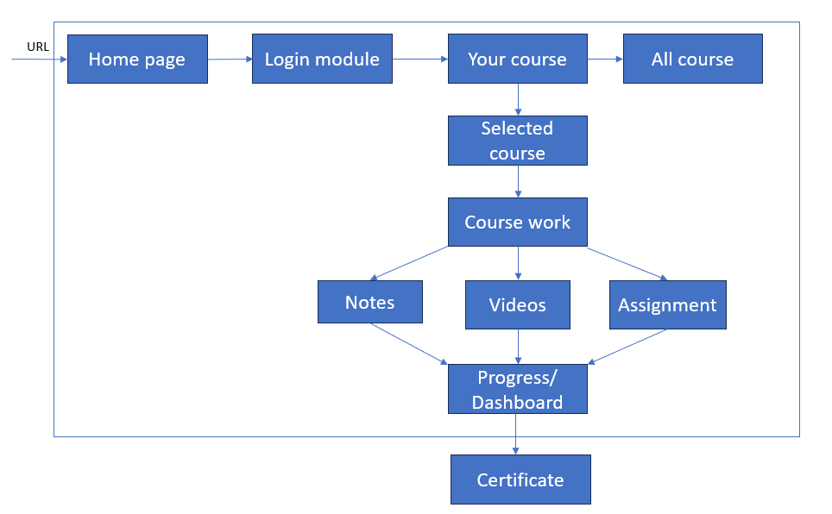

*Fig 3.1 Architecture of proposed system*

The proposed system starts with login, where login for faculty and student will be different, as faculty can have access to uploading and viewing the progress of every student whereas in student option is to only opt for courses where the student can see the videos regarding the selected course, can get teachers notes and module wise assignment to track his/her progress. All this record will be stored in the database.

Database will store all information from the start i.e. the login of teacher and student, the things uploaded and the record of every student.

## 3.2 Process Design

3.2.1 Login for student and professors

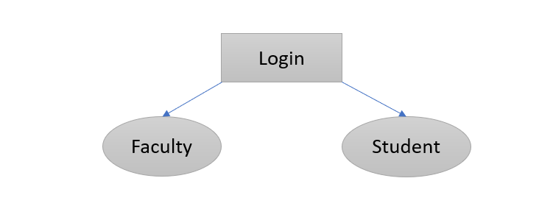

*Fig 3.2 login for student and faculty*

After creating a home page, which consists of a login page for faculty and students, Here the faculty will get different options for further working than the one for students.

3.2.2 Uploading and course selection

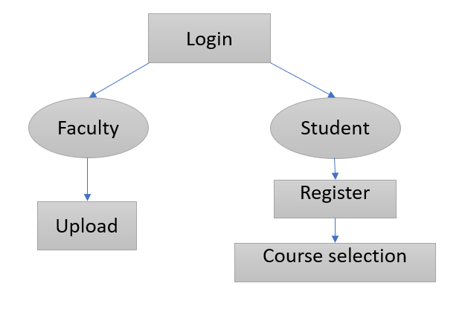

*Fig 3.3 Uploading and course selection*

After the login page the faculty gets the option for uploading the materials required for the specific courses, they even get reports and progress of every student.

For students, they get the list of courses and need to select atleast one for further process, maximum courses a student can choose is three. They need to finish the course within the span of 2 months.

3.2.3 Course

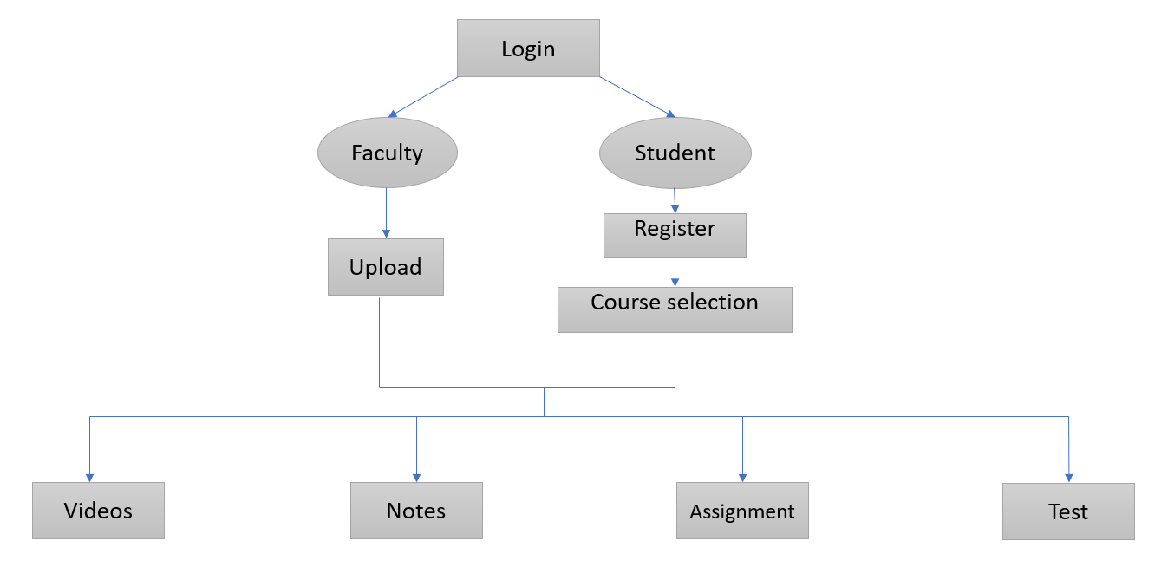

*Fig 3.4 Courses description*

With the course selected, students can view the videos, notes, give assignments on a weekly basis and have a final test for certification.

Faculty can upload all those things and can even view the record of marks and assignments done by students.

3.2.4 Database

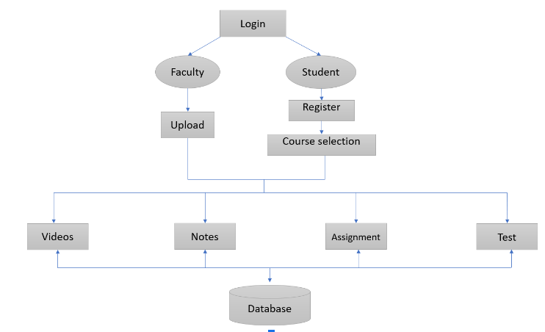

*Fig 3.5 Uploading and course selection*

All the data about the faculty, students, and uploading things can be stored in a database using MySQL.

Connection of MySQL can be done with help of Php.

## Details of Hardware & Software

### Software Used:

To build and operate the web application, the system has been built on Visual Studio Code.

### Languages Used:

The proposed system utilizes languages: HTML, CSS, JavaScript.

For the layout and design of the website HTML and CSS was used.

## Experiment and Results

Work was done on the project all semester long and have added some crucial functionality to the application.

In this semester, website has been generated from the student side of view, and will be completing both sides working till next semester.

The main features that the proposed system offers are as follows:

1. Upload the course notes, videos, assignment, and test
2. Allow students to view their own progress
3. Regular assignment to make their concepts strong
4. Having option to select maximum of 3 courses at a time, by giving the timeline to finish it within 2 months
5. Able to give scores to student based on their test performance immediately
6. Allows Faculty to view progress of every student
7. Fast generation of certificates within 3 days so they can upload in CV for better job/internship opportunities.

The detailed explanation of each page with their images for better and clear understanding is as follows.

* Homepage

The welcome page will have the options for the list of courses, Dashboard and the profile of the student showing how many courses completed till date, or the ongoing course with the percentage completed.

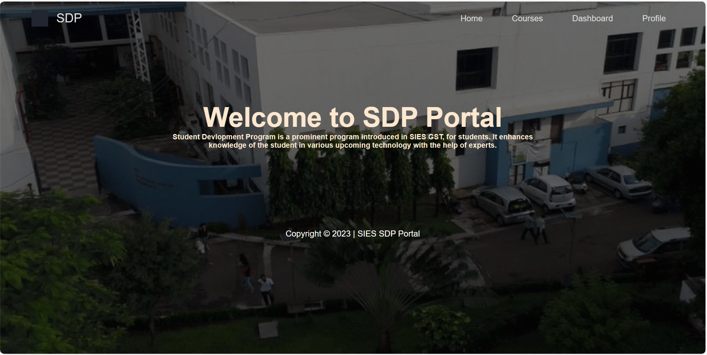

*Fig 3.6 Homepage*

* Courses selection list

This will give detailed information about the courses, the brochure, professor who will be teaching, the cost of the course and the duration needed to finish the entire course.

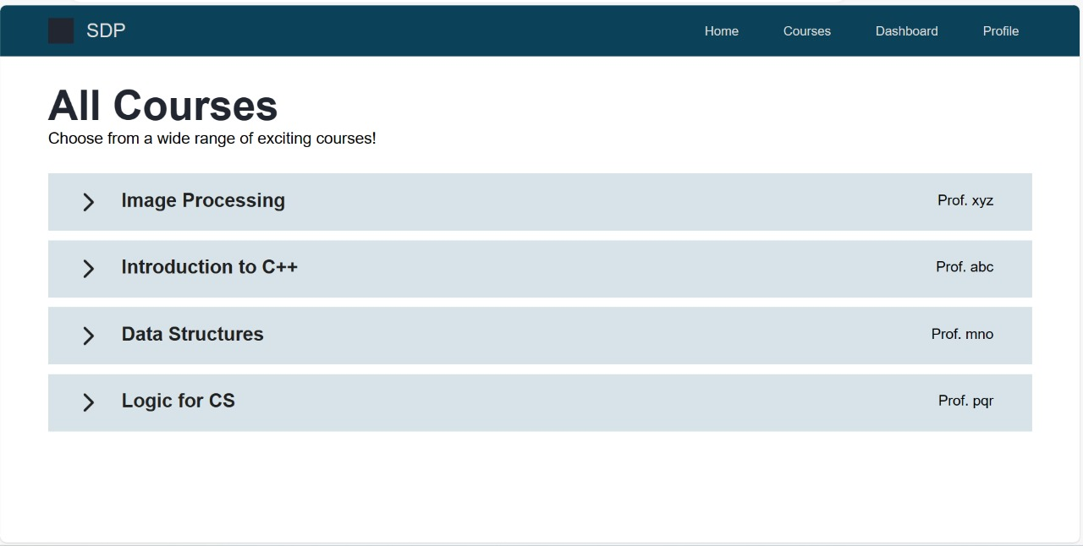

*Fig 3.7 Course selection list*

* Selected course list

This will show the courses selected for students. It will include short intro about what the course is about, the professor who will be teaching.

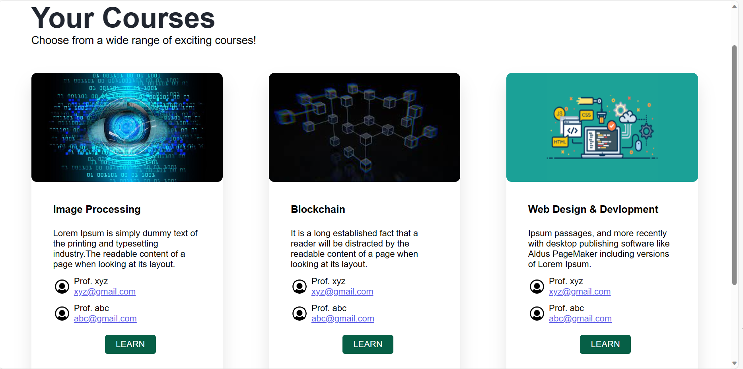

*Fig 3.8 Selected course list.*

* Login Module

This will show the login page for students and teachers.

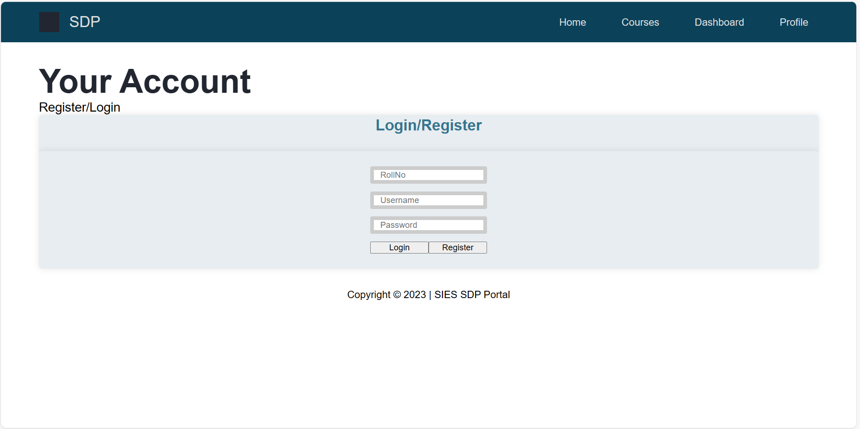

*Fig 3.9 Login Module*

# Chapter 4: Future Scope & Conclusion

## Future Scope

In this current project, our primary focus is on enhancing the student's learning experience by developing a fully functional website capable of facilitating video uploads and course-related tasks. However, looking ahead to the next semester and beyond, the plan is to expand and improve this platform to cater not only to students but also to faculty members, thereby creating a more comprehensive educational ecosystem.

One of our key objectives for the future is to create a website that empowers teachers to take an active role in content delivery and assessment. This means enabling teachers to upload educational videos, thereby sharing their expertise and knowledge with students directly. Moreover, the intention is to provide teachers with access to comprehensive databases containing student scores and progress data. This will enable educators to monitor and track their students' performance, identify areas where additional support may be needed, and recognize outstanding achievements.

A pivotal feature in our future development roadmap is the integration of a certificate generator within the website. This tool will utilize the database of student information to instantly generate certificates of completion. This streamlined process not only saves time for both teachers and students but also ensures the accuracy and reliability of these certificates. It represents a significant step towards making the educational experience more efficient and productive.

Furthermore, our vision extends to creating a user-friendly, intuitive, and secure environment that promotes seamless interaction between students and teachers. The portal intends to offer collaborative tools that allow teachers and students to communicate, share resources, and engage in discussions, fostering a sense of community and enhancing the overall learning experience.

In conclusion, our aspirations for the next semester include transforming our current project into a dynamic educational platform that caters to the needs of both students and teachers. This forward-looking approach seeks to empower educators, facilitate enhanced communication, and provide efficient tools for assessing and recognizing student achievements, ultimately creating a well-rounded and impactful online learning environment.

## Conclusion

## The role of an SDP in Engineering Courses, particularly one centered around web application development, is to bridge the gap between theoretical knowledge and practical application. It serves as a platform for students to apply what they have learned in the classroom to real-world projects, thus enhancing their problem-solving skills, critical thinking abilities, and creativity. By engaging in hands-on development of web applications, students can develop a deeper understanding of the principles they've been taught.

## Moreover, the integration of SDPs into the engineering curriculum helps students build a strong foundation in the latest technologies and tools related to web application development. The field of web development is dynamic, with new frameworks, languages, and best practices emerging regularly. An SDP equips students with the skills necessary to adapt to these changes, ensuring that they remain relevant in the job market.

## Another crucial aspect of an SDP is fostering a collaborative learning environment. Web application development often requires teamwork and communication skills. By working on projects in groups, students learn to collaborate, share ideas, and leverage each other's strengths. These experiences can be invaluable in their future careers, where teamwork and effective communication are highly valued.

## In addition to skill development, an SDP in web application development can also promote innovation and entrepreneurship among engineering students. The projects undertaken in the program can serve as a breeding ground for innovative ideas and potential startups. This entrepreneurial mindset can be instrumental in encouraging students to think beyond traditional career paths and consider entrepreneurship as a viable option.

## An SDP can also help engineering students gain a broader perspective of the impact of their work on society. By tackling projects that address real-world problems, students can see the practical implications of their engineering skills. This can be a powerful motivator and inspire students to use their knowledge and expertise to make a positive difference in the world.

## Furthermore, SDPs provide opportunities for students to gain exposure to industry experts and potential employers. Guest lectures, workshops, and collaboration with industry partners can give students insights into the latest industry trends and connect them with professionals who can provide guidance and potential job opportunities.

## However, it's essential to acknowledge the challenges and considerations associated with implementing an SDP in engineering courses. One significant challenge is resource allocation. Developing and maintaining a comprehensive SDP requires financial support, dedicated faculty, infrastructure, and access to the latest technology. Educational institutions need to make a substantial commitment to establish and sustain such programs.

## Another challenge is the need for curriculum flexibility. Engineering programs are often tightly packed with core courses, leaving little room for additional electives or SDPs. Therefore, institutions must find ways to integrate SDPs without overburdening students or stretching the duration of their programs.

## Additionally, assessment and evaluation are critical components of an SDP. Measuring the success of the program in terms of student learning outcomes, project quality, and impact on employability can be complex. Institutions need to establish robust assessment mechanisms to ensure that the SDP is meeting its intended goals.

## In conclusion, a Student Development Program (SDP) focused on web application development in engineering courses can be a transformative initiative with several benefits. It enables students to apply theoretical knowledge to practical projects, gain valuable technical skills, develop teamwork and communication abilities, foster innovation and entrepreneurship, and connect with industry professionals. However, it requires substantial resources, curriculum flexibility, and effective assessment to be successful. The implementation of SDPs in engineering programs can enhance the overall educational experience and better prepare students for their future careers. It empowers them with a holistic understanding of engineering, encourages critical thinking, and equips them to tackle real-world challenges. Furthermore, it aligns education with the dynamic needs of the industry, making graduates more competitive and adaptable in the job market. As education continues to evolve and adapt to the demands of the 21st century, the integration of SDPs in engineering programs becomes not just a desirable option but a necessity. To remain at the forefront of engineering education, institutions must invest in such programs to produce graduates who are not only knowledgeable but also highly skilled and well-rounded individuals ready to make meaningful contributions to society and the industry. The journey of building an SDP in web application development may be challenging, but the rewards in terms of student development and societal impact make it a worthwhile endeavor for educational institutions committed to excellence.

**References**

|  |  |
| --- | --- |
|  | [1] S. Wang, "Research on the Application of Computer Technology in the Information Construction of Student Status Management in Undergraduate Colleges," 2021 2nd International Conference on Information Science and Education (ICISE-IE), Chongqing, China, 2021, pp. 1201-1204, doi: 10.1109/ICISE-IE53922.2021.00270. |
|  | [2] D. K. Farkas, "A university Website design project: the design process, the prototype and some design issues," Proceedings of IPCC 97. Communication, Salt Lake City, UT, USA, 1997, pp. 311-319, doi: 10.1109/IPCC.1997.637059. |
|  | [3] Shiqian Chen, Chenliang Lil, Feng Ji, Wei Zhou, Haiqing Chen,, “Review Dricen Answer Generation for product related questions in E-Commerce,” *WSDM '19: Proceedings of the Twelfth ACM International Conference on Web Search and Data Mining,* pp. 411-419, 2019. |
|  | [4] C. Qing Zhang, C. Qiaoyan, H. Wande and W. Kai, "How to build an attractive corporate website — To business managers," 2011 International Conference on E-Business and E-Government (ICEE), Shanghai, China, 2011, pp. 1-4, doi: 10.1109/ICEBEG.2011.5886851. |
|  | [5] A. Dalvi and R. Saraf, "Inspecting Engineering College Websites for Effective Search Engine Optimization," 2019 International Conference on Nascent Technologies in Engineering (ICNTE), Navi Mumbai, India, 2019, pp. 1-5, doi: 10.1109/ICNTE44896.2019.8945823. |
|  | [6] Haejun Lee, Akhil Kedia, Jongwon Lee, Ashwin Paranjape, Christopher Manning, Kyoung-Gu Woo, “You Only Need One Model for Open-domain Question Answering,” in *Association for Computational Linguistics*, Abu Dhabi, 2022. |



|  |  |
| --- | --- |
| [11] | B. Yan, L. Jimei and X. Yan, "Quality of College Teaching-Aided Website Service: Case Study," 2009 Second International Symposium on Information Science and Engineering, Shanghai, China, 2009, pp. 45-49, doi: 10.1109/ISISE.2009.135. |
| [12] | Pandya, Anuj & Gawande, Namrata, “Automatic Generation of Minutes of Meetings,”  *International Journal of Scientific Research in Science, Engineering and Technology,* |

|  |  |
| --- | --- |
|  | vol. 9, no. 2, pp. 93-99, 2022. |
| [13] | T. Suksida and L. Santiworarak, "A study of website content in webometrics ranking of world university by using similar web tool," 2017 IEEE 2nd International Conference on Signal and Image Processing (ICSIP), Singapore, 2017, pp. 480-483, doi: 10.1109/SIPROCESS.2017.8124588. |
| [14] | U. Tiwari, S. Mehfuz, S. Sharma and V. T. Pandey, "Design of Python Based Lost and Found Website for College Campus," 2019 International Conference on Power Electronics, Control and Automation (ICPECA), New Delhi, India, 2019, pp. 1-5, doi: 10.1109/ICPECA47973.2019.8975541. |
| [15] | Xian Tang, "The investigation of learning websites in teaching English to college students," 2010 International Conference on Optics, Photonics and Energy Engineering (OPEE), Wuhan, China, 2010, pp. 280-282, doi: 10.1109/OPEE.2010.5507980. |
| [16] | Y. Chen, Y. Fan, X. Li and Y. Zhang, "A Crawler Detection Method for The College Entrance Examination Information Website," 2023 12th International Conference of Information and Communication Technology (ICTech), Wuhan, China, 2023, pp. 383-387, doi: 10.1109/ICTech58362.2023.00078. |
| [17] | W. Bin, G. Bingyun, L. Peishun and L. Xiaoqing, "A study on tactics for college website at search engine optimization," 2018 IEEE 3rd International Conference on Big Data Analysis (ICBDA), Shanghai, China, 2018, pp. 259-263, doi: 10.1109/ICBDA.2018.8367688. |
| [18] | Chen Yan, "An evaluation method for college library website based on evolutionary neural network," IET International Conference on Information Science and Control Engineering 2012 (ICISCE 2012), Shenzhen, 2012, pp. 1-4, doi: 10.1049/cp.2012.2383. |
| [19] | Majid, Ishfaq and Lakshmi, Y. Vijaya, Analysis of University Websites - A Study (August 19, 2020). Majid, I. & Lakshmi, Y. V. (2020).Analysis of University Websites - A Study. Research and Reflections on Education, 18(02B), 11-20., Available at SSRN: <https://ssrn.com/abstract=3804516> |
| [20] | D. K. Farkas, "A university Website design project: the design process, the prototype and some design issues," Proceedings of IPCC 97. Communication, Salt Lake City, UT, USA, 1997, pp. 311-319, doi: 10.1109/IPCC.1997.637059. |